Spruce Education

Home

* About
* Our Programs
* Our Admission Process
* College Advising
* Inquiry

Home

<https://www.choate.edu/>

***Top left info***

At the top left I would put the logo and organization name that is fixed to the top, even when you scroll. and at the top right I would suggest putting ‘Home’, ‘Our programs’ and ‘Contact Us’. Also fixed to the top.

For) example: (had to put screenshots so it will be more clear

SPRUCE EDUCATION: YOUR OVERSEA EXPERIENCE PROVIDER”

Featured Deals

Our News

Contact section (standard section repetitive at the end of each page and subpage)

***Bangers (Mission+Reputation)***

* This isn’t a subpage, but a show of muscle of Clinton High that Chinese parents care the most about.

Mission: A modern day and boarding high school—Three unique campuses day and boarding options.   
   
(Here we can add Clinton High’s unique strategy such as, idk, “Embrace Diversity, Strive for Excellence--- )

Reputation: What are our students’ average IB/SAT test scores? What are our college admission results (How many of our students go to Top 30 colleges?) What do students think about Clinton High (student satisfaction survey results)? What do colleges, the press, and educators think of this school?

Throw in statistics and content that impress Chinese parents.

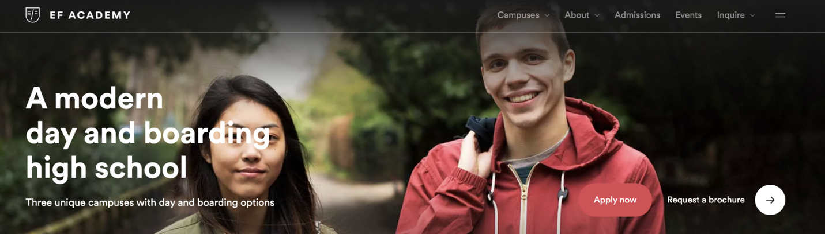

EF Academy Example

Dulwich College Example

**About**

About Spruce education：

Spruce Education is a premier education consulting company that specializes in helping high school students in China gain admission to top US universities. We have years of experience working with Chinese education consultants and high school headmasters to identify the best students and connect them with top US high schools.

Spruce opens a world of opportunities for high school students by providing them with a superior education, thorough preparation for university and a future that knows no borders.

Who We Are：

We are an international team truly passionate about education. We are a team of experienced educators and consultants who are passionate about helping students achieve their full potential. Our team includes experts in education, admissions, and international relations, who are dedicated to helping Chinese students succeed in the US.

What We Do：

At Spruce Education, we offer a comprehensive range of services designed to help Chinese students navigate the complex process of applying to US high schools and universities. Our services include student recruitment, application assistance, interview preparation, and cultural training. Unlock your potential at a boarding school that unites quality academics, co-curricular learning opportunities and personalized university guidance in a truly international campus environment.

What We Offer

We offer a unique opportunity for Chinese high school students to attend top US high schools, including Rivermont Academy High School and Clinton High. By enrolling in a US high school, Chinese students can gain valuable cultural experience and become eligible for admission to top US universities.

In addition, we personalize counseling and support to help students succeed academically and socially while studying in the US. One-to-one meetings with a designated university advisor, application workshops, test preparation and interview coaching are part of what set Clinton High Schools graduates apart when applying to university.

Whether you're a high school student in China or an education consultant looking to partner with us, Spruce Education is here to help you achieve your goals. Contact us today to learn more about our services and how we can help you succeed.

***Our Mission***

<https://www.fayschool.org/about/mission-and-philosophy>

We nurture each child’s potential through a broad, balanced, and challenging program that establishes the foundation for a meaningful life.

We envision a world where our students are intrinsically motivated and passionate young people who make a positive impact in the world. To this end, we see it as our mission to create opportunities and a learning ecosystem where our students can broaden and enhance their global, social and sustainable literacy to better understand their role in the world to make valuable contributions no matter what pathway they create.

Underpinning everything we do since we start are three pillars:

**1. Students Come First**- because we were founded by parents who wanted the best for their children and believe this means designing learning environments with the needs, talents and wellbeing of our students as the focus.

**2. One Family of Schools** – because we see the value of building a community for our students and providing a truly international education with unparalleled resources and learning experiences.

**3. Pioneering Spirit**– because we know that for our students to thrive in a rapidly-changing world and gain transferable skills that can be applied in diverse contexts, we must consistently seek to improve and innovate ourselves and our educational offering.

Our students are already beginning to make a difference as they enter the worlds of medicine, law, business, technology, the arts and public service. We can’t wait to see what they’ll do.

Philosophy

As a day and boarding school for students in Kindergarten through Grade Nine, Clinton High School is a community built on five core values: academic excellence; honorable conduct; dedicated service; earnest effort; and wellness of mind, body, and spirit. While the school has grown and evolved since its founding in 1866, our central purpose has remained constant. Fay provides a broad and challenging program that empowers students to discover their talents, develop their intellectual abilities, establish essential academic skills and knowledge, and define their moral character. Earnest effort has been emphasized throughout the School’s history, as enshrined in our motto, Poteris modo velis (“You can if you will”).

Clinton High School is dedicated to educating children to their full potential in the early childhood, elementary, and middle school years by helping them recognize and develop their intellectual, aesthetic, physical, social, and emotional capabilities. We teach our students essential, enduring skills: to read well, to write and speak clearly and coherently, to reason soundly, to question thoughtfully, and to study effectively. These skills support their ability to lead, to collaborate, to create, and to solve problems.

Love of learning brings us together, and we encourage our students to be curious, creative, and open to new ideas. Clinton High School’s safe and supportive environment allows students to take risks and encourages them to learn from mistakes, within the context of high expectations regarding academic performance and ethical conduct. Our teachers know their students as individuals and help them come to know themselves. As ~~Fay~~ Clinton High students grow, they develop an understanding and acceptance of their own challenges and strengths as learners.

Honesty, respect, responsibility, empathy, and kindness inform our conduct. The development of manners, civility, and integrity are hallmarks of our school. At every grade level, we emphasize an obligation to help ensure the well-being of others. As a home for boarding students from many cultures and backgrounds throughout the United States and around the world, ~~Fay~~ Clinton High is an inclusive community that recognizes, respects, and celebrates the full range of human diversity.

In all these ways, ~~Fay~~ Clinton High  prepares our students to lead productive and fulfilling lives that make a positive difference in the world.

***Featured News***

‘The latest news, events, ideas and happenings from across our family of schools’

*Events near you*

<https://www.efacademy.org/en-us/events/>

Meet us in person or online to learn more about the learning styles and global community at our private day and boarding high schools.

Personal consultation

Schedule a one-hour, one-to-one consultation with an admissions Consultant during which the whole family can get to know ~~EF Academy~~ Clinton High School

*One hour online or face-to-face meeting*

*Multiple dates available*

*Arrange your preferred time*

Book your personal consultation

Our programs

**~~Iowa~~** Clinton High School**~~High School~~ Summer Immersion Program**

General information about the immersion program

Students enrolling in ~~Fay~~Clinton’s English Language Program are full and integral members of the Upper School community, which is composed of 275 day and boarding students from more than 45 local towns, 15 American states, and 20 countries.

Students’ opportunities

Students have numerous opportunities throughout the school day and on weekends to participate in engaging, immersive activities that foster friendships and new interests. Students play a team sport each season, choose music and art electives, participate in after-school activities, compete in our color team competitions, share dorm rooms, and enjoy meals and social events with students from around the world. By using English continuously in meaningful contexts, students move closer to proficiency and fluency at a faster rate.

Life on a campus

Meet new friends from around the world who share your interests while living and learning on a college campus.

(Note: here you can put a video or photo album with a behind the scenes tour explaining the program and showing a quick glance of the immersion program)

***Program Overview***

Most English Language Program students will begin in grade seven or eight, with the goal of joining Fay’s mainstream classes in ninth grade as preparation for secondary school. The ELP program is composed of three courses. ELP students take all other courses-which include math, science, art-with their classmates.

* **Literature and Composition course:** students work on developing their reading comprehension, critical thinking, and writing skills. They read a variety of literary works, including novels, short stories, poems, and plays, and learn how to analyze and interpret them. They also practice writing essays, research papers, and other compositions, with a focus on improving their grammar, vocabulary, and organization.
* **American History course:** students explore the history of the United States from the perspective of Indigenous Peoples. They learn about the culture, traditions, and contributions of Indigenous Peoples, as well as the challenges they have faced throughout history. They also study the major events and figures in American history, with an emphasis on how they have impacted Indigenous Peoples.
* **Inquiry and Analysis course:** students develop research and study skills that are essential for success in secondary school and beyond. They learn how to conduct research, evaluate sources, and write papers that are well-organized and well-supported. They also learn how to analyze data, make informed decisions, and communicate their findings effectively.

ELP students take all other courses, including math, science, and art, with their classmates. This allows them to integrate with the mainstream student body and develop their social skills and cultural awareness.The ELP program provides a supportive and inclusive environment that is tailored to the unique needs of English language learners. It is staffed by experienced and dedicated teachers who are committed to helping students achieve their academic and personal goals.

Overall, the ELP program is designed to help English language learners achieve English fluency and develop the academic and social skills they need to succeed in secondary school and beyond.

***High Schools***

Rivermont High School

Rivermont Academy High School located in the beautiful city of Clinton, the school provides a safe and welcoming environment for students from all over the world.

Address and Location: Rivermont Academy High School is located at 123 Main Street, Clinton, USA. The school is conveniently located near the city center, with easy access to public transportation and local amenities.

Map Overview: Here is a map overview of the school's location:

[Insert map image here, with school location marked]

Clinton High School

Clinton High School is a highly located in the vibrant city of Clinton, the school provides a diverse and supportive community for students from all backgrounds.

Website: www.clintonhighschool.com.

Address and Location: Clinton High School is located at 456 Main Street, Clinton, USA. The school is conveniently located near downtown Clinton, with easy access to public transportation and local amenities.

Map Overview: Here is a map overview of the school's location:

[Insert map image here, with school location marked]

(Note: here you can add pictures of the schools on the left and on the right information and location etc.)

Our Admission Process

1. ***Speak to admissions.***

Our admissions Consultants will invite you to an in-person or online consultation – so you can get to know us and we can get to know you.

***2. Gather admissions documents.***

Documents include:

* Transcripts or report cards from last two years
* Scan of your passport
* Student photo
* Documentation regarding medical conditions, learning accommodations, and mental health, if applicable

***3. Complete an online application.***

Create your student profile and upload the requested admissions documents.

***4. Attend interview.***

This is your chance to tell us about your interests and ambitions, academic commitment, and motivation for coming to ~~[~~Clinton High and Rivermont Academy~~]~~. It is our chance to get to know you "off paper" for the best feel of how you will fit in and stand out as member of our school community.

***5. Admission decision.***

After making a holistic assessment of your application, you will receive our admissions decision. Successful applicants will receive an acceptance pack and our Admissions Consultants will help you finalize any documentation closer to departure. If you are traveling abroad to the UK, we will help obtain your visa.

***6. Prepare for new adventure!***

Get ready to start your journey at ~~[~~Clinton High and Rivemont Academy~~]~~ !

College Advising

***College Advising***

[The College Advising Office empowers students to take the lead in deciding where they’ll go after graduation, providing exceptional support, up-to-date resources, and expertise in the world of college admissions. We guide students as they consider a range of options for life after ~~Hotchkiss~~ Clinton high school/ Rivermont High School, teach them how to put together a college application that reflects their beliefs and talents, and help them choose the path that suits them best.] (paraphrase needed)

True Stories of Students who Succeeded Under College Advising

When xxx ’16 walked into Director of College Advising xxx’s office in the fall of his upper-mid year, he had no idea where he wanted to go to college. At Clinton High, science (xxx) had been xxx’s passion… (followed by a link that explains this story in detail).

College Handbook and School Profile

* Statistics of past university enrollments (how many of our students enrolled in Ivy Schools? US Top 30 schools)

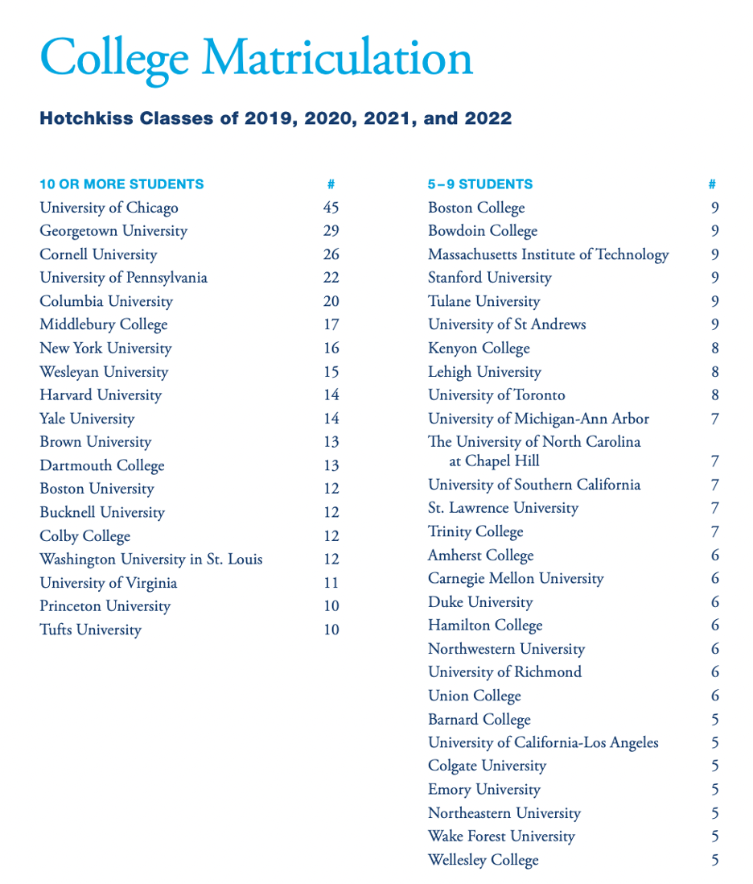

***Working with a College Advisor***

Although the College Office is crucial in assisting students with time management and organization throughout the college application process, it is ultimately the responsibility of the student to conduct research on post-graduation options, meet deadlines, and plan their future.

What a student should expect

In order for students to fully benefit from their connection with the College Office, they should take on the following obligations:

• Determine their individual and educational objectives

• Regularly engage with their college advisors

• Communicate with their families

• Research and comply with the distinct admission criteria and timelines (including standardized tests, curricular prerequisites, etc.) of each institution they apply to.

• Keep an updated list of college applications on Naviance.

• Supply all application materials and standardized test scores to every college or university they apply to.

The Role of a College Advisor

• Provide guidance with the utmost ethical and professional standards that align with Hotchkiss's values of integrity, honesty, and character.

• Send transcripts, ~~Hotchkiss~~Clinton High recommendations, and other secondary school materials to every college or university listed on a student's Naviance.

• Prompt students and families to investigate a variety of exceptional academic options both domestically and abroad, as well as other choices, such as a gap year, that could enhance a student's educational objectives.

• Stay in constant communication with parents during the college process.

• Safeguard the privacy of every student and maintain confidentiality regarding their personal information.

Inquiry

1. ***Contact Us***

Meet Our Team

Our advisors are professional individuals who have each had a long association with ABSI. Our advisors have assisted us on many occasions during our visits to their regions/countries.

* Titles

Content of titles

* Departments

Departments where the person works for

* Information

Email address

Phone number

(Note: Here you can put pictures of the team members with their titles, departments and email)



Social Media

Follow Spruce

* Facebook

Link to Spruce’s Facebook profile

For pictures, events, marketing etc.

* Instagram

Link to Spruce’s Instagram profile

For pictures, events, marketing etc.

* Twitter

Link to Spruce’s Twitter profile

For updates, pictures, events, marketing etc.

* Vimeo

Link to Spruce’s Vimeo profile

Sharing video content for marketing purposes or educational purposes.

* Flickr

Link to Spruce’s Flickr profile

For sharing video and photo content.

* LinkedIn

Link to Spruce’s LinkedIn profile

To inform what Spruce is and to gain attention for possible work candidates

* YouTube

Link to Spruce’s YouTube channel

For sharing video content having the purpose of marketing or education

(Note: here you can put some hyperlinks linking to the socials, so that you can follow the socials of spruce. just to keep in touch with them.)

1. ***Request a Brochure***

* 68 pages of information about our school and campuses
* Complete list of program and subject offerings
* Calendar of typical yearly co-curricular activities
* Understand our unique student guidance and support systems
* Annual fees and tuition

*Then we can put our form here, or/and in the next section of “schedule a consultation”

1. ***Schedule a Consultation***

* Meet us online or face-to-face
* Speak to an education expert and let us advise you on finding the right program
* Understand our unique student guidance and support systems
* Learn more about our admissions process and requirements

Submit our online inquiry form and a member of the Admissions Team will contact you to set up an appointment and answer any initial questions you may have.

***4. Login***

*In case we develop a portal/account for every registered student/applicant, we can keep this section and let it serve as an entrance to login.